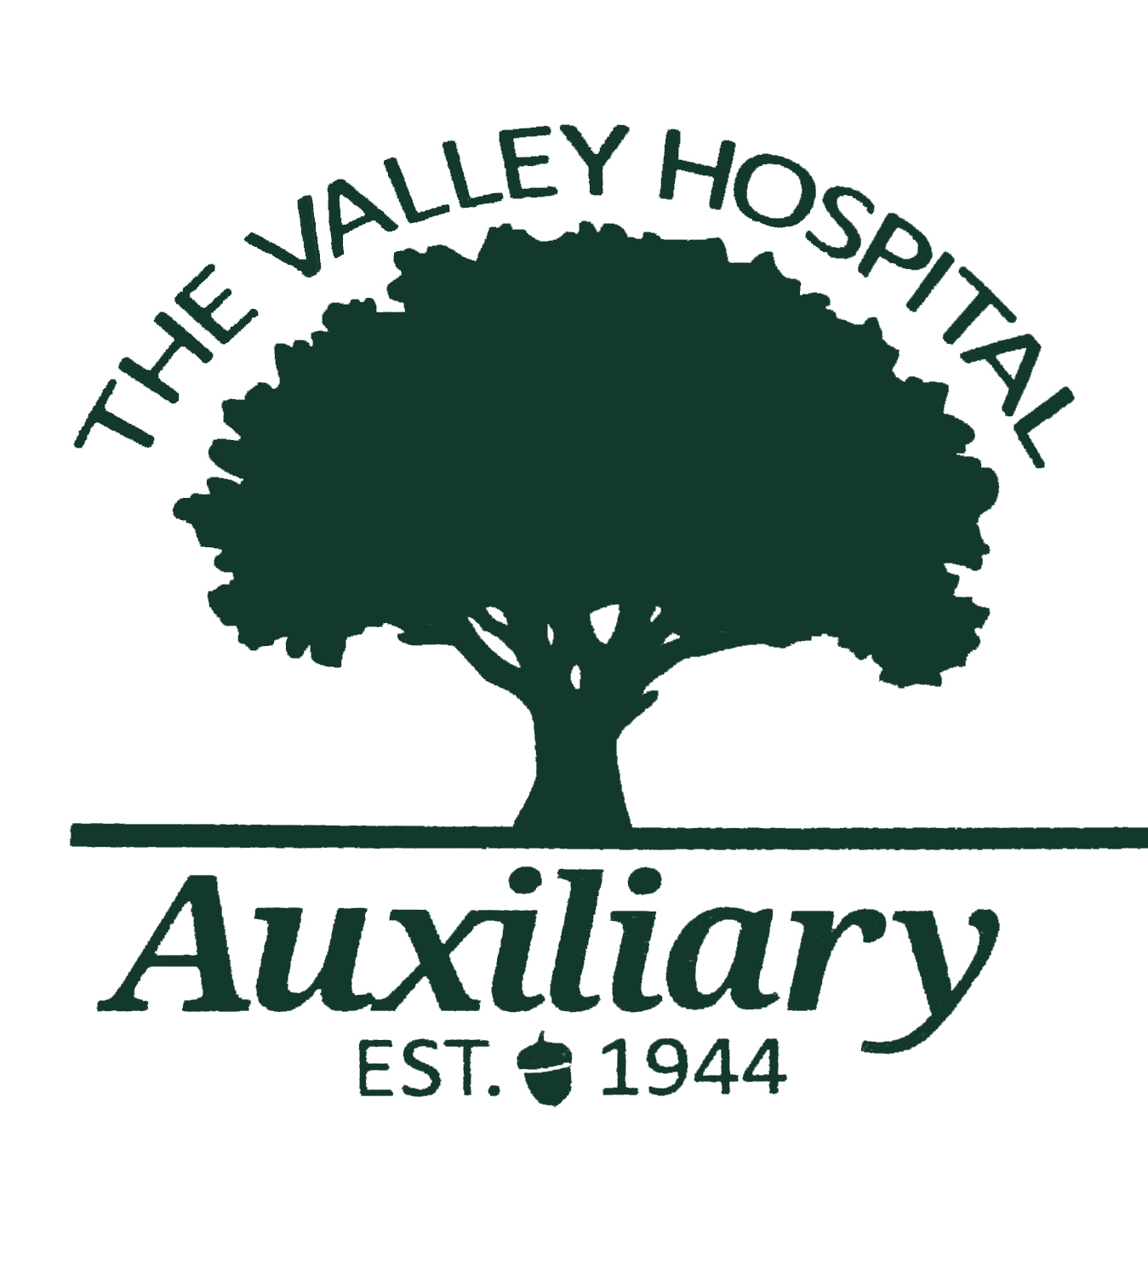
Valley Hospital Auxiliary High School Scholarship Letter and Application 2023
Dear Applicant,
You must be planning to major in a health-related field in order to be eligible for a Valley Hospital Auxiliary Scholarship.
The attached High School Scholarship Application (form VHA-HS2023) must be typed, fully completed and all requirements met in order to be considered as an applicant. Do not submit your application until you have obtained and included the following with your fully completed application with the three required signatures:
- Completed approx. 350 word essay
- Two letters of recommendation – if you work or volunteer, one recommendation should be from a supervisor or co-worker
- High school transcript of your grades
- Evidence of acceptance by your choice of school
- Before mailing in your application package, please have your guidance counselor confirm that it is fully completed as you will not be contacted if information is missing, and your application will not be valid.
When you have all of the above required, you must submit all of your information together
no later than April 28, 2023 and mail to:
The Valley Hospital Auxiliary
223 North Van Dien Avenue
Ridgewood, New Jersey 07450
Attention: Bonnie Dalal, Auxiliary Coordinator

Thank you for your interest in the Valley Hospital Auxiliary Scholarship.
Gabrielle Winnert and Carol Gillespie, Scholarship Committee Co-Chairs

